Alberta Health
SFTP User Guide
(Version 2.1)

Document Revision History
Version | Version Date | Summary of Changes | Author
V1.0 |  | Initial Release | IBM
V1.1 | September 25, 2015 | Updated to reflect changes as a result of the SFTP server migration. | CGI
V1.2 | June 28, 2016 | Updated to include method to reset password | CGI
V2.0 | July 23, 2018 | Overhaul to address support burden of Alberta Health business owners for external SFTP users. | CGI
V2.1 | August 15, 2018 | Made changes to 2.0 version requested by Alberta Health. | CGI

Table of Contents
1 Overview 5
2 File exchange with Alberta Health 6
2.1 Relationships 6
2.2 Exchange method and workflow 6
3 Responsibilities 8
3.1 Security and Privacy 8
3.2 Management of user accounts 8
3.2.1 Role of the Alberta Health business owner 8
3.2.2 When to make user account changes 8
4 Tasks 9
4.1 Installing SFTP software 9
4.1.1 Installing SFTP with Helpdesk support 9
4.1.2 Installing SFTP without Helpdesk support 10
4.2 Generating an SSH key pair 17
4.2.1 Purpose of an SSH key pair 17
4.2.2 Generating an SSH key pair with Helpdesk support 18
4.2.3 Generating an SSH key pair without Helpdesk support 20
4.3 Creating an SFTP account 25
4.4 Setting up SFTP software 27
4.4.1 Setting up SFTP software with Helpdesk support 27
4.4.2 Setting up SFTP software without Helpdesk support 29
4.5 Resetting an SFTP account password 34
4.6 Terminating an SFTP account 34

Overview
This document is a guide for users of Alberta Health’s secure file transfer service that are external to Alberta Health. It is intended to be provided to an external user by an Alberta Health business owner as a guide to setting up and maintaining information exchange. New versions will be available in the Application Document Library in the Alberta Health Architecture Repository under “Infrastructure Support”, and should be distributed by Alberta Health business owners to external users.

File exchange with Alberta Health
Alberta Health has established a secure file transfer service to enable the secure transfer of sensitive information between Alberta Health and other parties.

Relationships
The service manages all the relationships between particular business areas at Alberta Health, and external users or organizations, called “submitters”. (The common case is for Alberta Health to receive data from external parties, but submitters can also be consumers of data.) A submitter can be an application, a team, or an individual. In the case of the team, multiple user accounts will exist, and will all see the same files.
Submitter B
External Team
Alberta Health Business Area 1
Secure File Transfer Service
Submitter A
External Application
Submitter C
External User
Alberta Health Business Area 2
Alberta Health Business Area 3
…
…

Exchange method and workflow
To implement the secure file transfer service, Alberta Health operates servers running a system called “GoAnywhere”. This name appears in emails sent by the system, and is used in some processes and documentation. The GoAnywhere system can be accessed with different technologies: website, SFTP(Secure File Transfer Protocol), etc.; however, for security reasons, only SFTP is available to external users.
A user using SFTP to access the Alberta Health Secure File Transfer Service will see a submitter area with the following folder structure:
- UPLOAD
  - This folder is where files going to Alberta Health must be put. After a short while, the system will remove the file from this folder and place it in another folder (not visible to you) where Alberta Health will be able to see it.
- DOWNLOAD
  - This folder is where files coming from Alberta Health will appear.
  - Important: Files are automatically deleted from the DOWNLOAD folder after 15 calendar days. The secure file transfer service is not an archival service, and has limited storage capacity.
  - Files can also be deleted manually – we recommend deleting the files after you have downloaded them and verified their contents.
- HELP
  - This folder contains a read-only text file with information on terms of use for the system. It is not used in day-to-day information exchange activity.
Each submitter has its own folder structure, and a corresponding folder structure exists for the Alberta Health side as well. As a user, you will only see your submitter area and not those of other submitters or of Alberta Health.

Responsibilities

Security and Privacy
The Alberta Health secure file transfer service enables security and privacy, but only in partnership with users and organizations. Authentication details such as passwords and private keys must be kept secret, or they can be used to impersonate a user. Computers must be kept secure and up-to-date, to protect authentication details and private information downloaded from the service. Compliance to all applicable laws and regulations is required.

Management of user accounts

Role of the Alberta Health business owner
User accounts are set up to access submitter areas in the secure file transfer service. The submitter area is associated with a corresponding Alberta Health business area. The Alberta Health business owner is your partner in user account management, as they must approve changes to user accounts that access information from their business area.
Password resets are an exception to this general rule and do not need to involve the Alberta Health business area.

When to make user account changes
New user accounts can be created as needed as people join your team. The process for creating a new account is provided in section 4.3, “Creating an SFTP account”.
A user account should be terminated if the account is no longer required. This could be due to an employee leaving the organization (examples: transferred, resigned, terminated, retired, etc.). Also, this could occur if your organization no longer exchanges information with Alberta Health using the secure file transfer service. The process for terminating an SFTP account is provided in section 4.6, “Terminating an SFTP Account”.
A user account should have its password reset in response to certain events. The password should be changed if it is accidentally exposed, such as it being accidentally included in an email or present on systems that have been hacked or breached. The password should also be changed whenever support personnel for your external application leave the support team and had knowledge of the password used by the application. The process for resetting a user account password is provided in section 4.5, “Resetting an SFTP Account Password”.

Tasks

Installing SFTP software
As an external user, in order to connect to the Alberta Health secure file transfer service using SFTP, you must have SFTP software installed on your computer. The SFTP protocol is implemented by various software packages with varying business models.

Installing SFTP with Helpdesk support
If your organization has a Helpdesk that supports you, you should contact that Helpdesk to determine if SFTP software is already installed on your machine.
If it is not installed, your organization may have selected a standard SFTP software package, or might have an approved list of SFTP software packages with a preferred option. In that case, you should request to have that software installed on your machine.
If your organization has not yet selected a standard SFTP software package, and does not permit installation of software packages by users, then a request must be made to select and then install an SFTP software package.
If your organization does not have a standard SFTP software package, but permits installation of software by users, proceed with the instructions in the next section, 0.
Your organization’s firewall must allow outbound connections on TCP port 22.

Installing SFTP without Helpdesk support
Disclaimer
Alberta Health does not supply or support SFTP software.
This section provides instructions on how to install the WinSCP package on Microsoft Windows. However, the choice of WinSCP and these instructions are provided only as an example. At the time of writing, this software package (5.13.3) was free and open-source, and did not bundle additional software.
Ultimate responsibility for evaluating software (including software licensing) and supporting software remains with your organization, and not Alberta Health.
Follow these steps to install the WinSCP SFTP package:
- Download the software installer from https://winscp.net/.
- Launch the WinSCP Setup.exe file.
- Verify the application signature is as expected, and click “Run”.
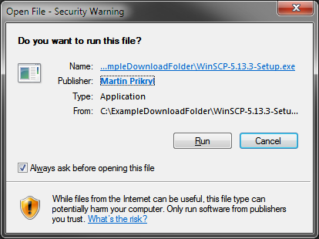
- Review and evaluate the license agreement. If acceptable, proceed using the “Accept” button.
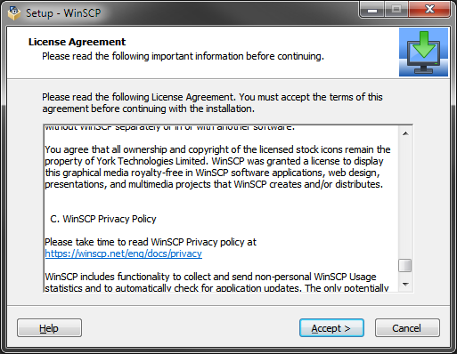
- Select a “Typical” installation, and click “Next”.
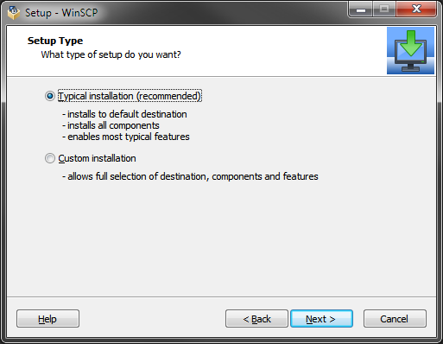
- Select the “Explorer” user interface style (the default), and click “Next”.
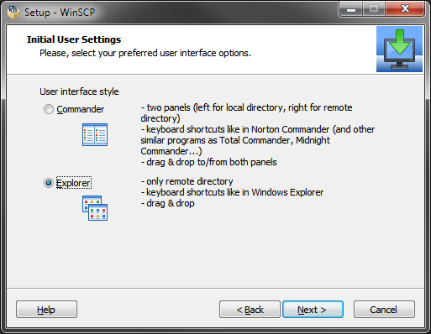
- Click “Install” to begin the installation process.
- Wait for the installation step to finish
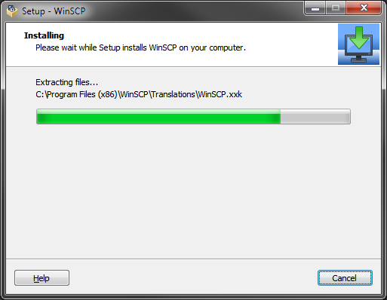
- Click Finish, which will open a general getting started guide for the software, and launch the program.
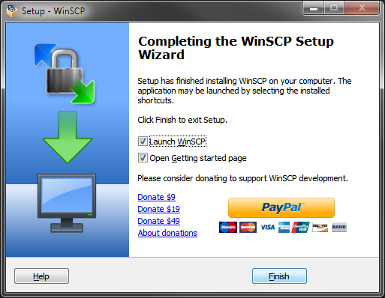
Next steps:
0 The output of the key generation will be two keys, which are usually represented as files. If there is no designated area for saving the keys, you can save the public key to the Desktop with a .public_key extension, and the private key can be saved in an “SFTP Keys” folder under your documents. The public key is often given the .pub extension, although this is also used by Microsoft Publisher.
If opened in a text editor such as Notepad, the content should look like this:
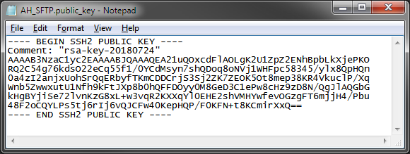
The public key will be needed when creating an SFTP account, as described in section 4.3, “Creating an SFTP account”.
The private key must be kept secret, including from Alberta Health. It will be used to set up the connection to SFTP, as described in section 4.4.1, “Setting up SFTP Software with Helpdesk Support”.

- Generating an SSH Key Pair without Helpdesk Support
- 4.3 Creating an SFTP account
0 This task requires:
- your organization’s Helpdesk to have selected and installed SFTP software on your machine, as per section 4.1.1, “Installing SFTP with Helpdesk support”
- your organization’s Helpdesk to have created a private key or to have assisted you in the creation of a private key, as per section 0, “Generating an SSH Key Pair with Helpdesk Support”
- you to have an SFTP user account created, as per section 4.3, “Creating an SFTP account”
Your organization’s Helpdesk will have to assist you in configuring the connection in the SFTP software. This may be a service they provide, or it may be that they refer you to the documentation for the SFTP software.
The connection feature will require parameters, some of which may be set beforehand, and some of which may be asked for when connecting. The parameter values should be set as follows:
Parameter | Value | Comments
Host name | getfile.health.alberta.ca
Port | 22 | This should be the default value
User name |  | This is the identifier of the SFTP user account.
Authentication methods | Password and public key | This parameter may be implicit – for example, if you provide both a password and a private key, both will be used.
Password |  | This is the password of the SFTP user account.
Private key |  | This will be the private key file you have previously generated.
Private key password / passphrase |  | If you opted to secure your private key with a password or pass phrase when the key was saved, then it will be needed as well.

- Setting up SFTP Software without Helpdesk Support

Generating an SSH Key Pair

Purpose of an SSH Key Pair
The SFTP protocol is a specific application of the more general Secure Shell (SSH) protocol. One of the common features offered by SSH is authentication. Multiple authentication methods are implemented in SSH, among them passwords and asymmetric encryption keys. Asymmetric encryption relies on a pair of keys. One key is public, and is sent to others. The other key is private, and is kept as a secret from others, just like a password. The public key can be used to encrypt data such that only the holder of the private key can see it, and the public key can be used to validate that data comes from the holder of the private key. To set up the key pairs to work this way, they must be generated and then stored, rather than chosen and remembered (as with password).
To enhance the security of the Alberta Health secure file transfer service, SFTP users must authenticate with both a user id/password and asymmetric encryption key. This provides two-factor authentication: the password is something you know (factor 1), and the private key is something you have (factor 2). This raises the difficulty of a successful attack, as a hacker must obtain multiple pieces of information. However, it also means that if your private key is on one computer, you will only be able to use SFTP on that computer, as you will be missing one of the two factors on other computers.
Remember that your private key is a secret, as is your password. It should not be shared with anyone, including Alberta Health. Your private key should be stored securely on a machine with access controls, and if transferred between machines, the transfer method should be secure.

Generating an SSH Key Pair with Helpdesk Support
This task requires your organization’s Helpdesk to have selected and installed SFTP software on your machine, as per section 4.1.1 (“Installing SFTP with Helpdesk support”).
Your organization’s Helpdesk will have to assist you in generating an SSH key pair. This may be a service they provide, or it may be that they refer you to the documentation for the SFTP software. Generation of SSH key pairs is a usual feature of SFTP software.
The generation feature should have various adjustable parameters, which should be set as follows:
Option | Required value | Common values (to confirm the correct option is being manipulated) | Comments
Format | SSH-2 | SSH-2, SSH-1 | May be combined with algorithm – SSH-1 only supports the RSA algorithm
Algorithm | RSA | RSA, DSA, ECDSA, ED25519 | May be combined with format.
Key bit size | 2048 | 1024, 2048, 4096
Password / passphrase | No requirement |  | You can optionally secure your private key with a password, which would be required to use the key. This configuration would mean that two passwords and the private key would be needed to log into Alberta Health SFTP. The two passwords are separate and must not be confused.
The output of the key generation will be two keys, which are usually represented as files. If there is no designated area for saving the keys, you can save the public key to the Desktop with a .public_key extension, and the private key can be saved in an “SFTP Keys” folder under your documents. The public key is often given the .pub extension, although this is also used by Microsoft Publisher.
If opened in a text editor such as Notepad, the content should look like this:

The public key will be needed when creating an SFTP account, as described in section 4.3, “Creating an SFTP account”.
The private key must be kept secret, including from Alberta Health. It will be used to set up the connection to SFTP, as described in section 4.4.1, “Setting up SFTP Software with Helpdesk Support”.

Generating an SSH Key Pair without Helpdesk Support
This section provides a guide to generating an SSH key pair using WinSCP, the software installed in section 0, “Installing SFTP without Helpdesk support”.
Follow these steps:
- Open WinSCP, if it is not already running.
- In the “Tools” menu on the connection dialog, select the “Run PuTTYgen” option. PuTTYgen is a separate component for generating SSH key pairs.
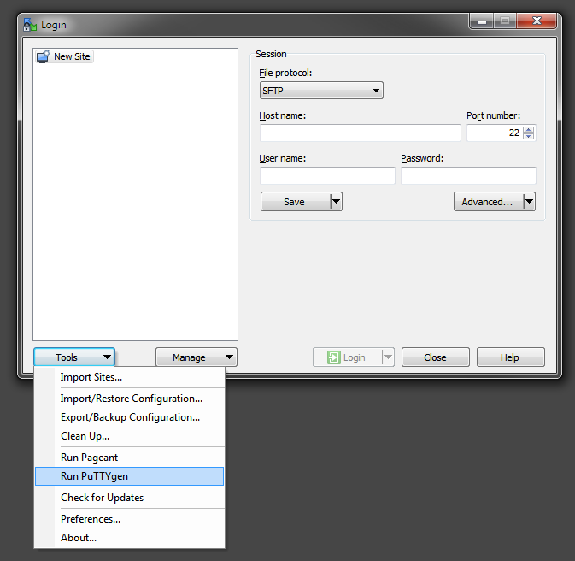
- Ensure the configuration is for “RSA” and a key size at least 2048 bits. Then click the “Generate” button.
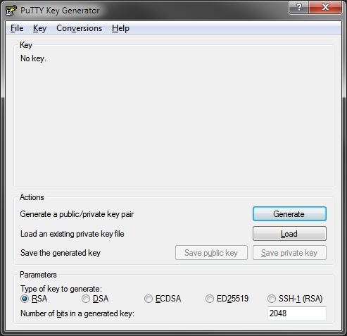
- Follow the instructions provided near the top of the following screen to contribute randomness to the key. This step takes some time.
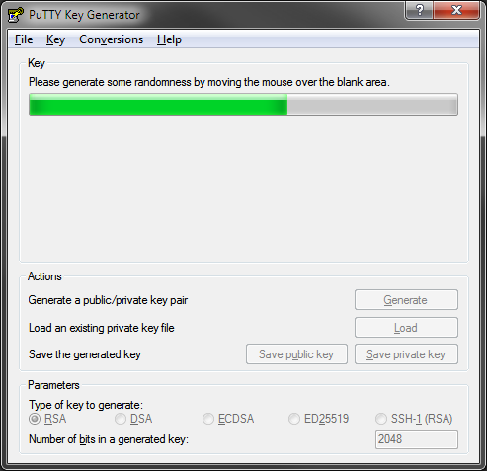
- Once the generation is complete, save the public key to a file, using the “Save public key” button. For example, you could use the name AH_SFTP.public_key, and save it to the Desktop.
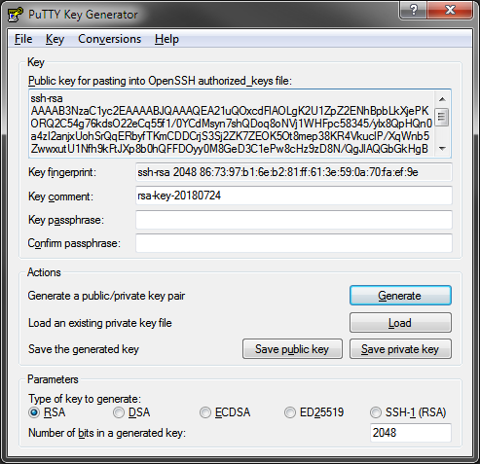

- For additional security, a passphrase can be set on the private key. If a private key passphrase is used, then when the user logs into Alberta Health SFTP, the user’s password, the private key, and the private key passphrase will be required. If a passphrase is not provided, only the private key and the user’s password will be required.


- Click the “Save private key” button. If a passphrase has not been provided, an additional confirmation will be required. Save the private key in an appropriate place, for example, as a “AH_SFTP.ppk” file in a “SFTP keys” folder under your documents.

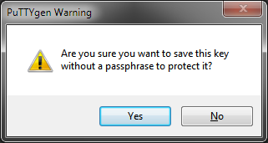
- Close the generator window.
- Close WinSCP using the “Close” button.
You will send the generated public key on your Desktop to Alberta Health as part of the request to create an SFTP account as described in section 4.3, “Creating an SFTP account”.
The private key in your documents must be kept secret, and should not be sent to Alberta Health or anyone else. It will be used when connecting to SFTP as described in section 0, “Setting up SFTP Software without Helpdesk Support”.

Creating an SFTP account
A request to create an SFTP account must go through an Alberta Health business owner, as the owner must add additional information and provide their approval for the request.
At a minimum, the following details are required when creating an SFTP account:
- User’s first name
- User’s middle name
- User’s last name
- User’s business phone number
- User’s email address
- An SSH public key (see section 4.2, “Generating an SSH Key Pair”)
If the SFTP account is for a new user that is being added to an existing submitter group, this detail should be included in the request. (For an explanation of the relationship between Alberta Health business areas, submitters, and external users, see section 0, “File exchange with Alberta Health”.)
Individual Alberta Health business areas may require additional steps or information outside of the minimum required for the secure file transfer service, and may designate particular contact points for account requests.
Once the appropriate information is provided and the Alberta Health business owner approves, the internal “SFTP User ID Registration” form will be filled out and then processed by Alberta Health.
The GoAnywhere system that implements the Alberta Health secure file transfer service will email the user when the account is created. Two emails are sent: one includes the user ID, and the other includes the password. Only the SFTP interface to GoAnywhere is available outside of Alberta Health, so references to other interfaces (such as the website) in the emails should be ignored.

Setting up SFTP Software
Once a user id has been created as per section 4.3 (“Creating an SFTP account”), the SFTP software installed as per section 4.1 (“Installing SFTP software”) must be configured to access Alberta Health.

Setting up SFTP Software with Helpdesk Support
This task requires:
- your organization’s Helpdesk to have selected and installed SFTP software on your machine, as per section 4.1.1, “Installing SFTP with Helpdesk support”
- your organization’s Helpdesk to have created a private key or to have assisted you in the creation of a private key, as per section 0, “Generating an SSH Key Pair with Helpdesk Support”
- you to have an SFTP user account created, as per section 4.3, “Creating an SFTP account”
Your organization’s Helpdesk will have to assist you in configuring the connection in the SFTP software. This may be a service they provide, or it may be that they refer you to the documentation for the SFTP software.
The connection feature will require parameters, some of which may be set beforehand, and some of which may be asked for when connecting. The parameter values should be set as follows:
Parameter | Value | Comments
Host name | getfile.health.alberta.ca
Port | 22 | This should be the default value
User name |  | This is the identifier of the SFTP user account.
Authentication methods | Password and public key | This parameter may be implicit – for example, if you provide both a password and a private key, both will be used.
Password |  | This is the password of the SFTP user account.
Private key |  | This will be the private key file you have previously generated.
Private key password / passphrase |  | If you opted to secure your private key with a password or pass phrase when the key was saved, then it will be needed as well.

Setting up SFTP Software without Helpdesk Support
This task requires:
- you to have installed WinSCP on your machine, as per section 0, “Installing SFTP without Helpdesk support”.
- you to have created a private key, as per section 0, “Generating an SSH Key Pair without Helpdesk Support”
- you to have an SFTP user account created, as per section 4.3, “Creating an SFTP account”
Follow these steps to configure WinSCP to connect to Alberta Health via SFTP:
- Launch WinSCP.
- Enter getfile.health.alberta.ca in the “Host name” field. Enter your user name in the “User name” field. Ensure the “File protocol” is SFTP, and the port number is 22.
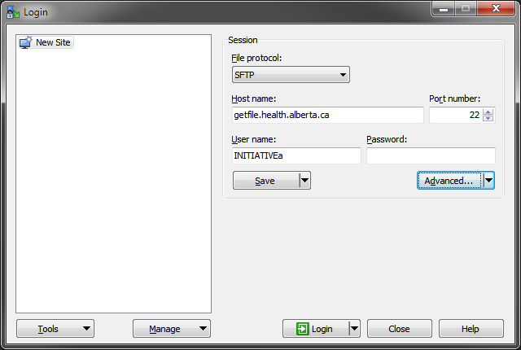
- Select the “Session > Advanced…” item under the “Advanced…” menu button.
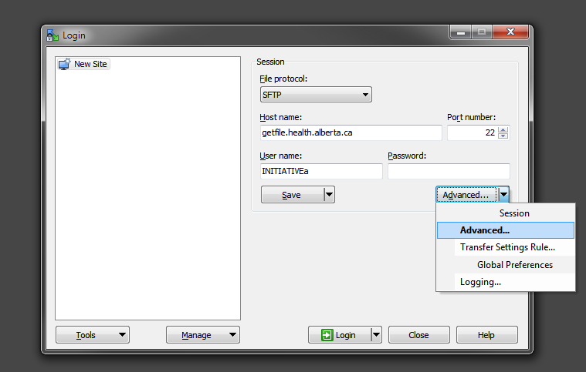
- Select “SSH > Authentication” in the tree on the left. In the “Private key file” field, click the browse button to navigate to the folder containing the private key file. (The suggestion in section 0 was to save it as “AH_SFTP.ppk” in a “SFTP keys” folder in your documents.) Click “OK” to exit the dialog”
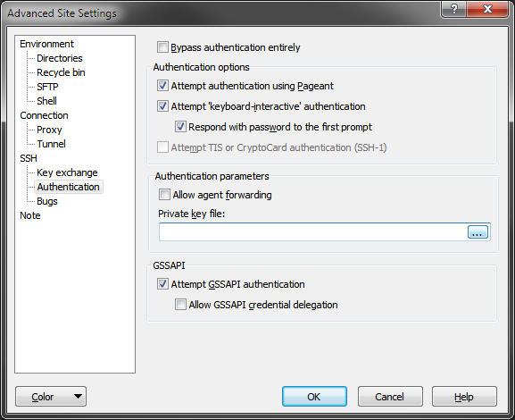
- Click the Save button. In the next dialog, provide a name for the saved connection information and click “OK”.
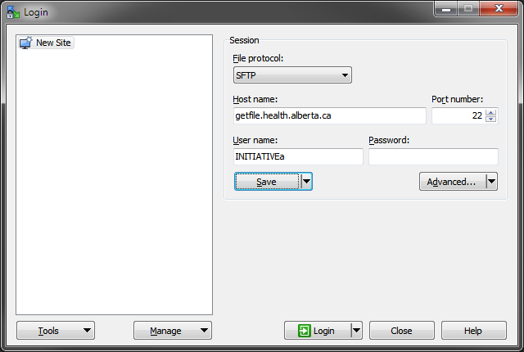
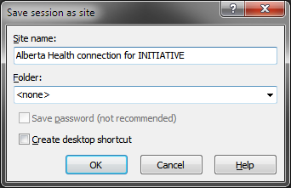
- Click the Login button.
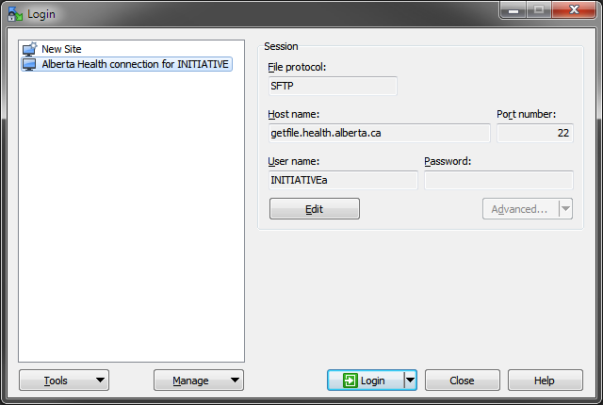
- As this is the first time the software is connecting with the machine, it will present the following dialog. The expected values for the presented details will change over time and if they do this step will be presented again. Click Yes to proceed.
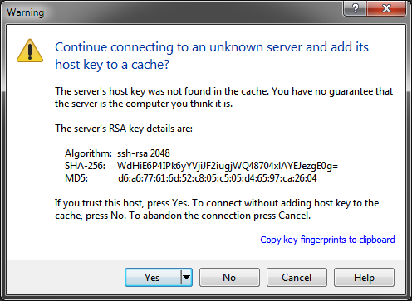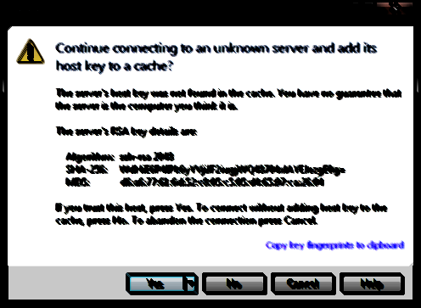
- You will be prompted for your private key password/passphrase, if you opted to set one up. You will then be prompted for your user password/passphrase.
- Once connected, you can transfer files by dragging and dropping them to and from Explorer windows.
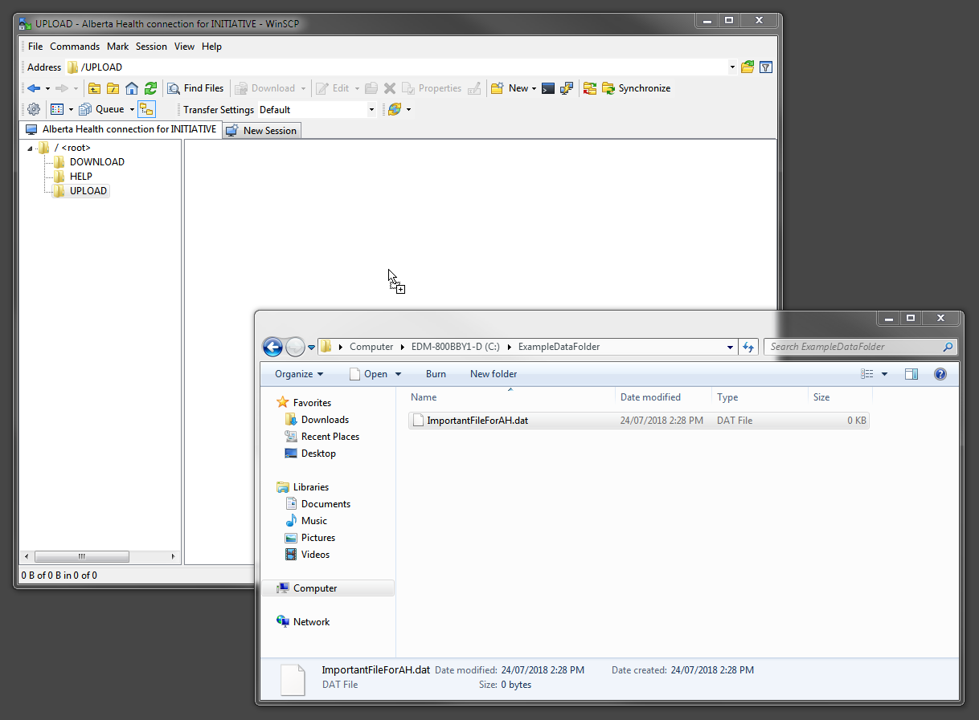
- The first time a transfer is made, the following dialog will appear to set up transfer options. The defaults are appropriate. Click “OK”.
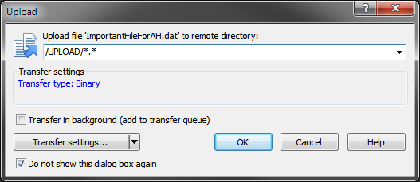

Resetting an SFTP Account Password
Resetting an SFTP account password does not require the involvement of the Alberta Health business area.
To reset your SFTP account password:
- Phone the Government of Alberta Help Desk at 1-888-427-1GOA (1-888-427-1462). In the Edmonton area, you can use the local number 780-427-1462.
- Tell the operator that you require a password reset for an Alberta Health GoAnywhere account. (GoAnywhere is the name of the system that provides the Alberta Health secure file transfer service.)
- Provide the operator with the account’s username.
The Service Desk will create a password reset request, and the GoAnywhere system will email the user a new password. Only the SFTP interface to GoAnywhere is available outside of Alberta Health, so references to other interfaces (such as the website) in the emails should be ignored.

Terminating an SFTP Account
If an SFTP account is compromised or is no longer needed, it should be terminated. A request to terminate an SFTP account must go through an Alberta Health business owner, as the owner must add additional information and set the priority of the request.
A termination request should include the following information:
- The user name.
- Whether the closure should be expedited (for example, in the case of an abrupt employee termination).
- Whether the associated submitter group should also be removed, or if the user is one of many and the submitter group should remain. (For an explanation of the relationship between Alberta Health business areas, submitters, and external users, see section 0, “File exchange with Alberta Health”.)
Individual Alberta Health business areas may require additional steps or information outside of the minimum required for the secure file transfer service, and may designate particular contact points for account requests.
Once the appropriate information is provided and the Alberta Health business owner approves, the internal “SFTP User ID Registration” form will be filled out and then processed by Alberta Health to terminate the account.

